Newsletter 2020

PILGER SENIOR CENTER
100 W. 2nd St., Suite #100
Pilger, NE 68768
Phone 402-396-7363

Pilger Senior Center Newsletter
January 2020

Welcome to the January edition of the Pilger Senior Center Newsletter.

The Board of Directors will have their meeting on Thursday, Jan. 9th, at 5:00 pm.

Meals: Please remember that we must have meal reservations by noon the day before the day you would like to join us for lunch! Our phone number is 402-396-7363. If no answer, leave a message on the voicemail. Meals will be served Monday thru Friday, with lunch meals at noon. For anyone 60 and over there is a suggested donation of $5. No meal reservation will be accepted if you call to the Dairy Keen. All meals must be called into the senior center

Birthday Party: We will be having our celebration for the Jan. birthdays on Jan. 15, 2020. We will be having our Health Clinic, then noon lunch, with Bingo following. We have cake & ice cream after Bingo. The meal for the day is going to be Turkey Club Sandwich, Mac Salad, Beets, Cranberry Salad, & Milk.

Wisner Care Center: Wisner Care Center will not be coming this month.

Manager’s Notes:
I’ve added more videos for FROGs. Hopefully you can come and check them out.
The Ice Cream Machine is up and going! We will sell cones for $1, a dish for $2 and a quart for $5. We will now have soft serve ice cream for our birthday parties as well!! Most of the time we will have vanilla, chocolate, & twist. In the summer we may do a different flavor once and awhile.

Voting Ballot-Don’t forget to vote for the next board members to join the Senior Center Board. Last day for voting is Thurs. Jan. 9, 2020 by 4 pm.

Email: If you would like to get your newsletter sooner, I am taking emails if you have one. This
will save some money for the center and you will have it as soon as I get it done. If you would
like to receive the newsletter this way, then send me an email at
pilgerseniorcenter@outlook.com , Subject: Newsletter. Then I will have your email and know
you want to receive the newsletter through email.

Donated Items We Need for The Senior Center
Decaf Coffee
Postage Stamps
Paper Plates

Important Phone Numbers
Pilger Senior Center | 402-369-1138  402-396-7363
NE Area on Aging | 402-370-3454
Care Line | 1-888-370-7003
Social Security Admin. | 1-800-772-1213
Veterans Admin. | 1-800-827-1000
Hospice Link | 1-800-331-1620
Medicare | 1-800-633-4227
Legal Aide of Nebr-Elder | 1-800-527-7249

Wishing Our January Birthdays’
A Happy Birthday!

7th - Joan Tiedtke
10th – Cindy Raabe
14th – AJ Kluthe
19th – Mary Hunke
20th – Betty Felt
21st – Jeanette Brummond
22nd – Tim Tinker
Anniversary
If you know someone that is having a birthday and isn’t on the list Please let me know so I can add them! I don’t want to miss anyone!

THANK YOU TO ALL!
All individuals and groups who volunteer their time and talents here daily, weekly and monthly! Thank you for all those who eat here on a regular basis! We appreciate your patronage. And Thank You to anyone who donates to us by either participating, monetary, or items we need! We appreciate all that EVERYONE does!! THANK YOU!!
Serve the Lord with gladness. Psalm 100:2

Current Pilger Senior Center Board Members
AJ Kluthe – President
Kim Dunklau – Treasurer
Melanie Thompson – Secretary
Lyndy Labenz – Vice President
Jim Duncan – Member
Cory Voecks – Member
Ron Siecke – Member
Wendy Jindra – Manager

Calendar of Events
January
Wednesday, Jan. 1, 2020 – New Year’s Day (Center CLOSED)
Monday, Jan. 20, 2020 - Martin Luther King Jr. Day

February
Sunday, Feb. 2, 2020 – Groundhog Day
Wednesday, Feb. 12, 2020 – Lincoln’s Birthday
Friday, Feb. 14, 2020 – Valentine’s Day
Saturday, Feb. 15, 2020 – Senior Center Valentine’s Day Supper (Windsor Loin/Skewed Shrimp - $30 per person)
Monday, Feb. 17, 2020 – Presidents’ Day
Saturday, Feb. 22, 2020 – Washington’s Birthday
Wednesday, Feb. 26, 2020 – Ash Wednesday

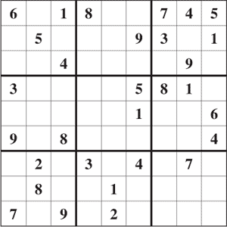

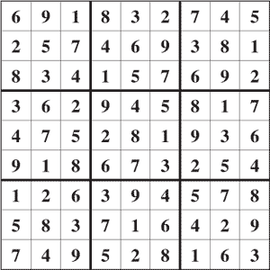
Answer to Puzzle

