June
Newsletter 2020

PILGER SENIOR CENTER
100 W. 2nd St., Suite #100
Pilger, NE 68768
Phone 402-396-7363

June 21st – Father’s Day

Pilger Senior Center Newsletter
June 2020

The Board of Directors will be having their next board meeting on Friday, June 26, 20 at 4:30 pm. Until further notice we will not be allowing our meetings open to the public due to COVID-19. I will be including some of the items that were discussed in the newsletter. If you have any concerns or want any more information, please contact Ron Siecke at 402-396-3382 or Wendy at (402)396-7363.

Manager’s Notes:
Please remember, as of the date that I was typing this newsletter I have not heard about when
the Senior Center can open back up.

Meals are going over very well. I am very happy to be able to see some of you and talk through
glass as well. It makes my heart sing getting to see you! Please remember that meals need to
be called in by 3 pm the day before. If I do not answer the phone please leave a voicemail for
me. I will check the messages around 3:15 pm to get everyone down. For the Monday menu, I
will allow everyone to call by 3 pm on Saturday.

We have been donated mask and gloves. So, if you are need of these items please let me know
and I will drop them off to you.

The menu is going to have less beef items. With all this going on the prices of beef have also
majorly increased for the food establishments as well.

I want everyone to know the steps that we take in delivering your meal. We are using brand
new T-shirt carry-out bags, we hand sanitize our hands before and after every time we touch
the to go meals. I also wipe the inside and the outside of each cooler we use every day after
each use.

Meal Delivery Procedure:
Everyone has been doing a FANTASTIC job with the delivering of meals. I appreciate all the
steps everyone is doing on keeping our distance yet being able to see each other. You put
a smile on my face! If you are thinking that you would like a meal, but you think you might live
too far out of town, please call and talk to me! You will be surprised the directions I am
traveling to deliver meals so I maybe already going by your home or delivering very close by! If
you would like a meal this is the procedure we need to follow; I cannot be in contact with
anyone for my safety and yours. So, I will leave your meal by the door, ring the doorbell, or
knock on your door and return to my vehicle. Once I am by my vehicle you may pick up your
meal.If you have any questions, please call me!
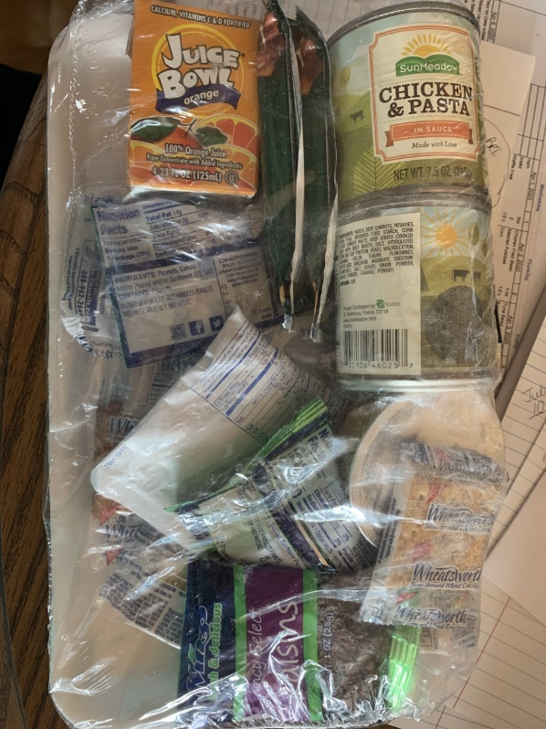

I still have several of these meal kits. I am going to start just handing them out with everyone that receives meals. If you do not want them you can pass them on to someone else. But they really are not doing any good sitting on my counter. In them is a juice box, 2 soups, saltine crackers, raisins, granola bars, apple sauce, and powder milk. These are free to anyone 60 and over, and it is on a first call base. If you would be interested in receiving 1, 2 or 3 of these packages please let me know. I will deliver them the same way that I deliver the meals. There are 2 meals per package.

Board Meeting Topics
March
38 III C-1 60+
0 III C-1 60U
38 meals 9 serving days in March

April
121 III C-1 60+
17 III C-1 60U
138 meals 13 serving days in April

March 2020 Checking account- started $8,243.93 ended $7,217.93.
CD- $22,858.70

April 2020 Checking account- started $7,217.93 ended $7,390.32.
CD- $22,858.70

Meeting with CFCC
April 1 meeting with CFCC Board. Kim, Ron, and AJ attended.
Contract changes
#1- NO long term price freeze.
#7- The refrigerator in the Senior Center was purchased by the CFCC. The refrigerator was repaired and the Senior Center paid for the repair bill. If it needs to be replaced, the Senior Center will buy a new one and return the old one to the CFCC.
#14- No sub rental of Senior Center Space while we maintain rent that is in good standing, unless approved by the Senior Board. Example CFCC and Senior Center co sponsor a fundraiser that would include use of the every room of the CFCC.
#23- Contributions for the hall rental birthdays. 1 birthday party is included
1.- $10 use per day for equipment other than Dishwasher and electricity.
- Includes senior walkers in the hall, yoga by the fireplace, etc.
- A form should be filled out minimum 4 days prior to use and submitted to CFCC manager for record keeping.
2.- Pay for dishwasher soap and use the kitchen equipment as needed.
- The use of the hall for additional birthdays will be $10.
- A form should be filled out minimum 4 days prior to use and submitted to CFCC manager with payment for record keeping.
3.- Requested that the Kitchen be removed from the contract or explained better.

Donated Items We Need for The Senior Center
Postage Stamps
Any Kind of Canned Fruit
Whole Wheat Bread
Whole Wheat Flour
Important Phone Numbers
Pilger Senior Center | 402-369-1138  402-396-7363
NE Area on Aging | 402-370-3454
Care Line | 1-888-370-7003
Social Security Admin. | 1-800-772-1213
Veterans Admin. | 1-800-827-1000
Hospice Link | 1-800-331-1620
Medicare | 1-800-633-4227
Legal Aide of Nebr-Elder | 1-800-527-7249

THANK YOU TO ALL!
All individuals and groups who volunteer their time and talents here daily, weekly and monthly! Thank you for all those who eat here on a regular basis! We appreciate your patronage. And Thank You to anyone who donates to us by either participating, monetary, or items we need! We appreciate all that EVERYONE does!! THANK YOU!!

Current Pilger Senior Center Board Members
Ron Siecke – President
Cory Voecks – Vice President
Kim Dunklau – Treasurer
AJ Kluthe – Secretary
Jim Duncan – Member
Gayle Lampman – Member
Jeff Warren - Member
Wendy Jindra – Manager

Calendar of Events
July
Saturday, July 4, 2020 – Independence Day

Wishing Our June Birthdays’
A Happy Birthday!
6th – Daryle Urwiler
6th – Ken Wiechman
9th – Jeff Warren
12th – Peggy Hunke
15th – Kenny Karloff
15th – Ted Reeg
17th – Jerry Meyer
18th – Eva Peterson
23rd – Kathie Lierman
27th – Beverly Sprieck
Anniversary
If you know someone that is having a birthday and isn’t on the list Please let me know so I can add them! I don’t want to miss anyone.

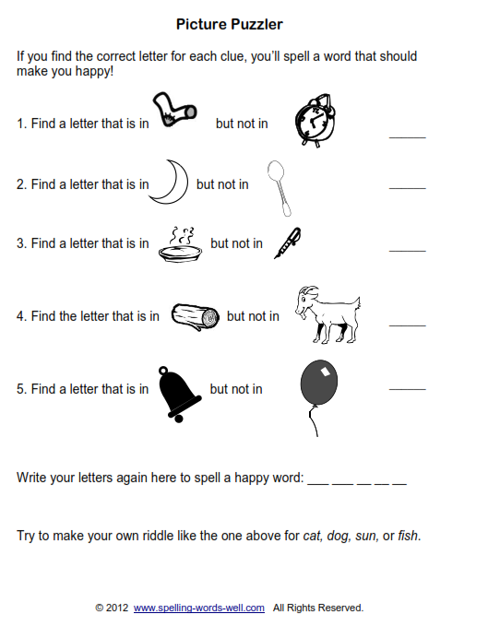

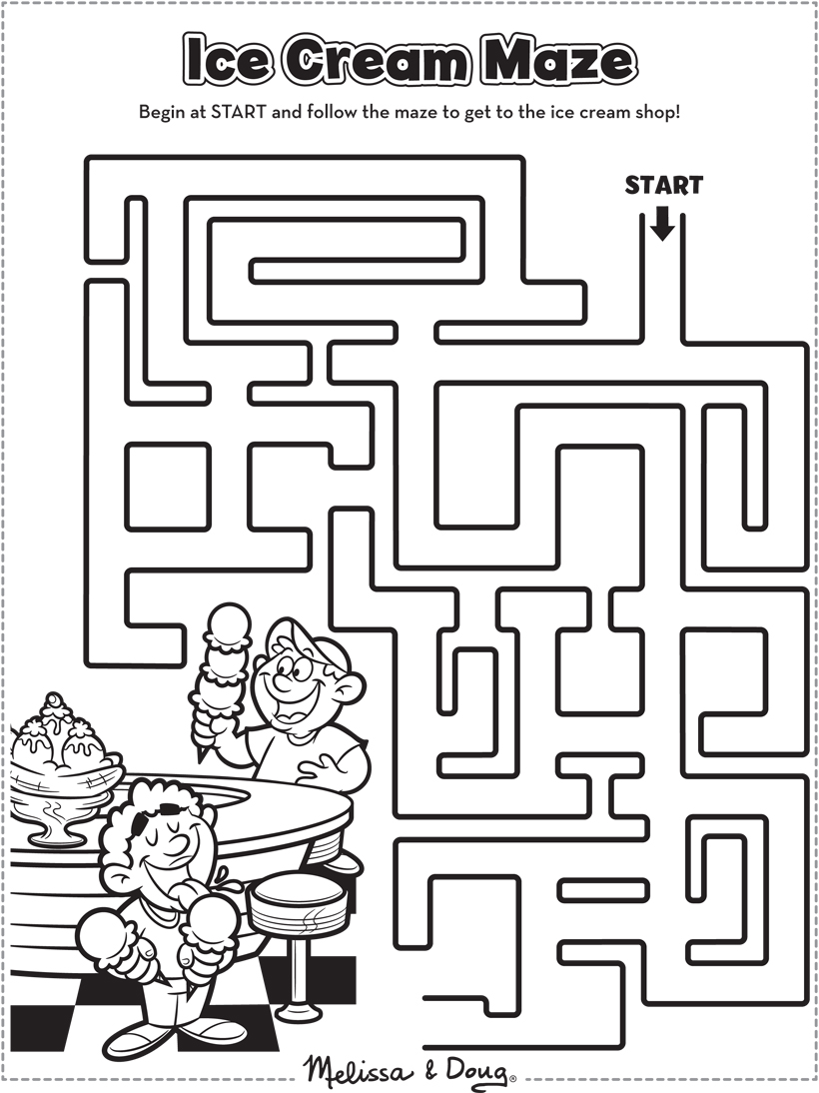

Answer to Picture Puzzler: SMILE

